1 . Connectors
a. permanently join two fiber ends.
b. make temporary connections between two fiber ends or devices.
c. transmit light in only one direction.
d. merge signals coming from many devices.

2. Index-matching gel
a. holds the fibers in place.
b. keeps dirt out of the space between fiber ends.
c. prevents reflections at fiber ends.
d. eliminates effects of numerical aperture mismatch.
e. all of the above

3. What is the excess loss caused by the mismatch in core diameters when a
connector transmits light from a 62.5/125 multimode fiber into a 50/125
multimode fiber?
a. 0 dB
b. 0.19 dB
c. 0.8 dB
d. 1.9 dB
e. 12.5 dB
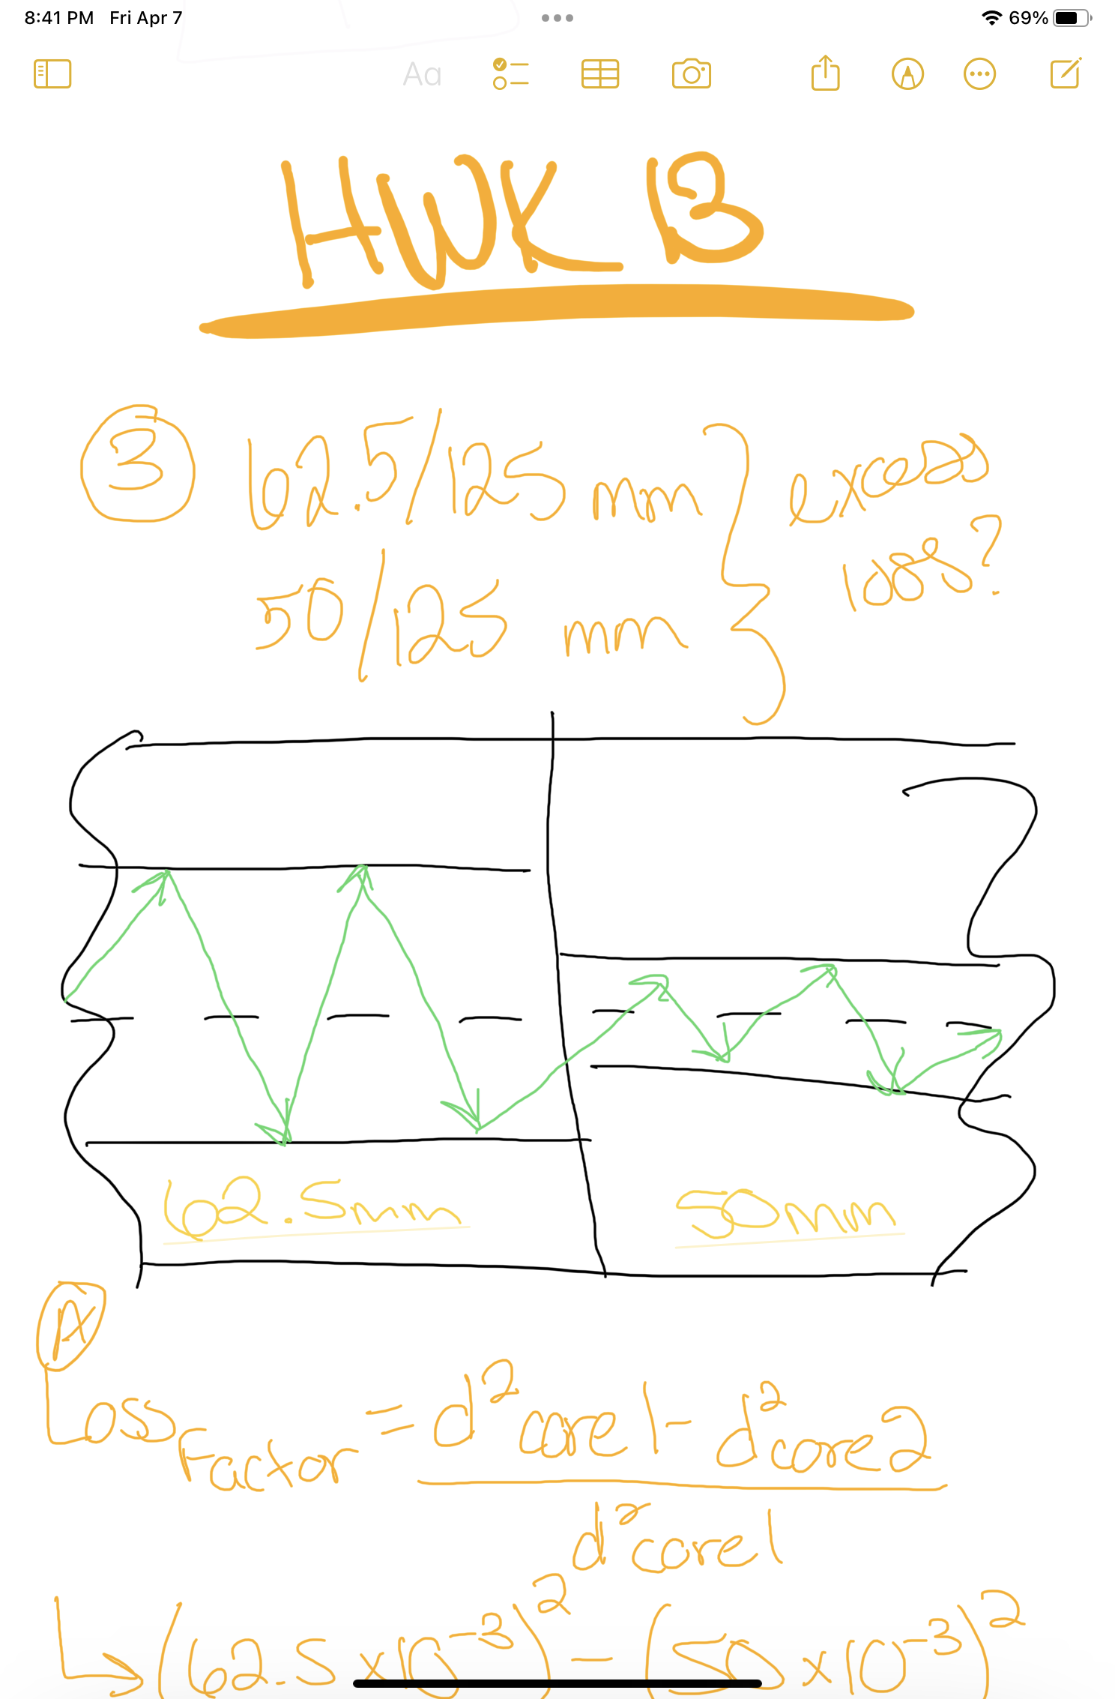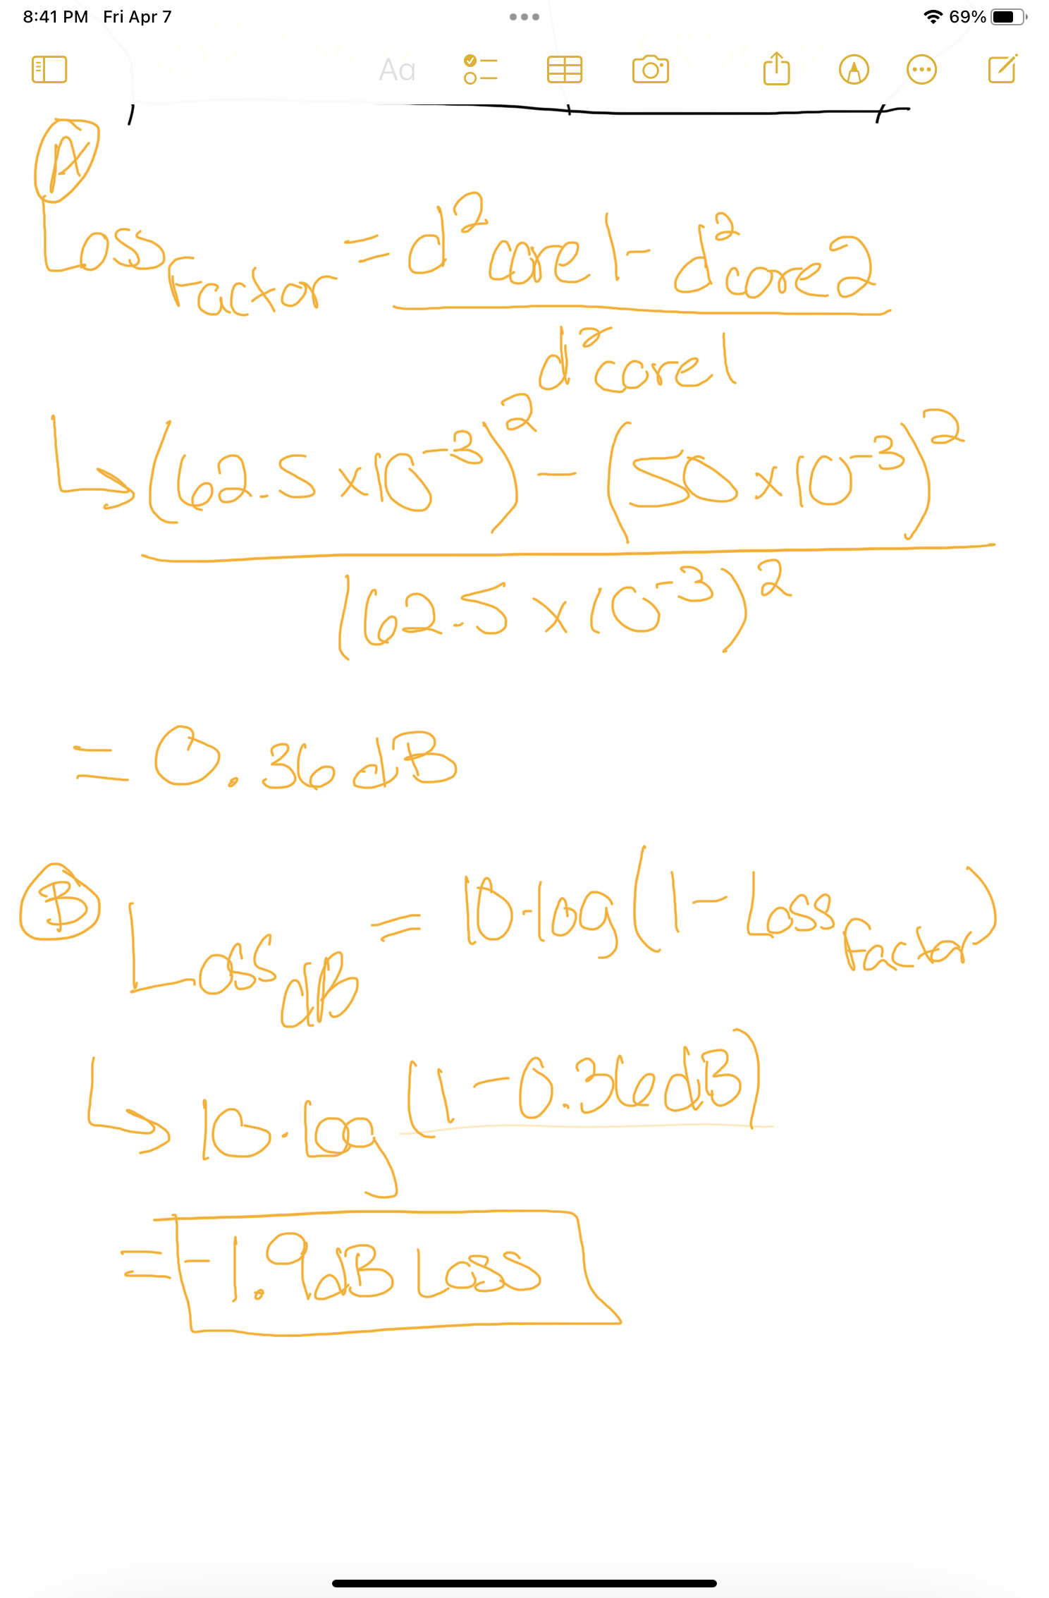

4. The largest excess loss probably will occur in which case?
a. transfer of light from a single-mode to a multimode fiber
b . when an air gap o f 2 (Jtm is left between identical fibers
c. when a 20-fxm soot particle is spliced near the core of a pair of single mode fibers
d. when a 2° angle is left between a pair of fibers when they are spliced
e. when index-matching gel is left out of a mechanical splice

5. How many matings and unmatings is a typical fiber-optic connector rated to survive? a. 100
b. 1000
c. 10,000
d. 100,000
e. 1 million

6. Ferrules do what in a fiber-optic connector?
a. relieve strain on the cable
b. allow adjustment of attenuation Connectors and Splices
c. hold the fiber precisely in place
d. prevent back-reflection

7. How does an SC connector attach mechanically to an adapter or patch panel?
a. It pushes straight in and snaps into place.
b. with a special tool
c. It must be screwed into place.
d. It twists with a bayonet-type latch.

8. Which of the following mechanisms is not used in small form-factor connectors?
a. Latching in place like telephone jacks.
b. Twisting in place like coaxial-cable connectors.
c. 1.25-p.m miniature ferrules.
d. V-groove alignment.
e. Mounting a pair of fibers in a single ferrule.

9. Splices
a. permanently join two fiber ends.
b. make temporary connections between two fiber ends or devices.
c. transmit light in only one direction.
d. merge signals coming from many devices.

10 . Typical splice loss is around
a. 0.01 dB.
b. 0.1 dB.
c. 0.5 dB.
d. 0.8 dB.
e. 1.0 dB.

11 . What would happen if fibers with identical outer diameters but different core diameters were spliced together?
a. The splice would fail mechanically.
b. Loss would be high in both directions.
c. Loss would be high going from the large-core fiber to the small-core fiber, and low in the opposite direction.
d. Loss would be high going from the small-core fiber to the large-core fiber, and low in the opposite direction.
e. impossible to predict

12. Splice housings are important because they
a. reduce splice attenuation.
b. protect splices from physical and environmental stresses.
c. prevent hydrogen from escaping from splices.
d. allow measurement of splice attenuation.
e. contain light sources.

